Mapping AR Codes to Yardi

1) ADMINITSTRATION--> FINANCIAL--> AR CODES
2) Use the FILTER function to narrow down the results: ie. Parking
3) Click on the AR code in question

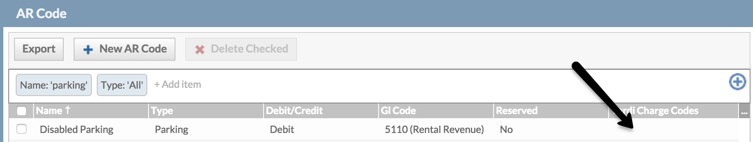

4) Click Edit
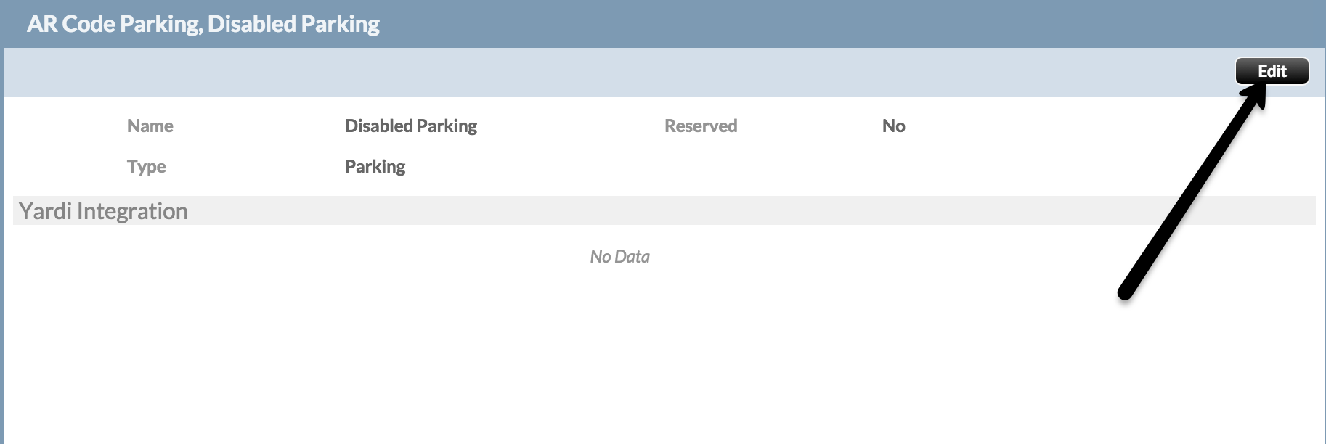
5) +ADD and add in the Yardi equivalent code EXACTLY as found in yardi. Example: rrent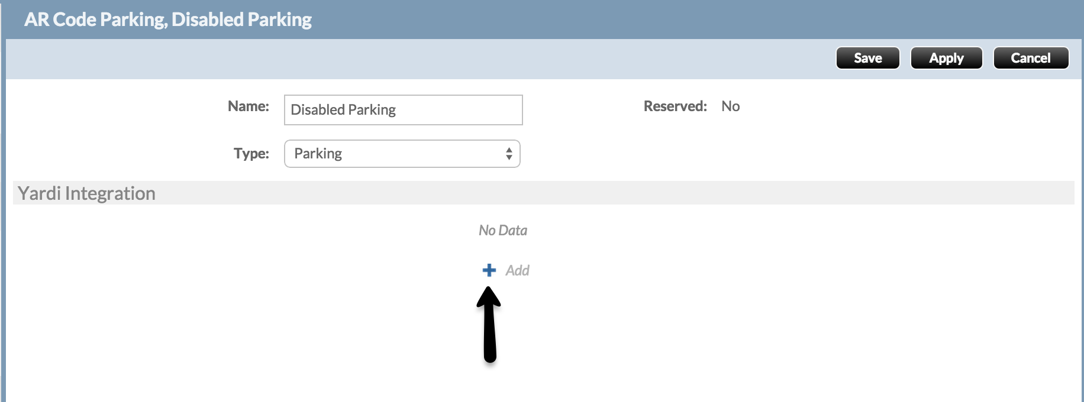
6) Click SAVE
